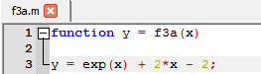3a) 

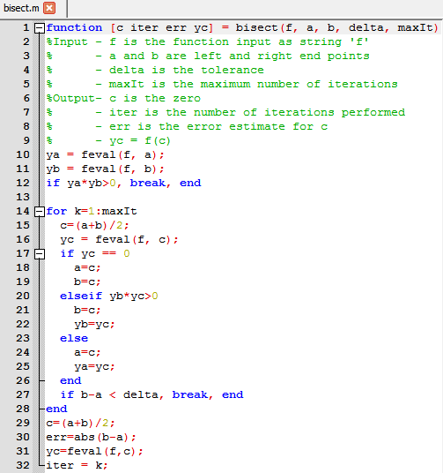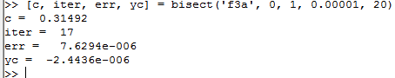3b)

3c)

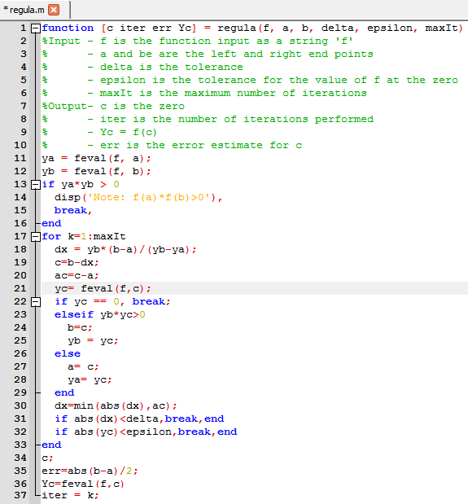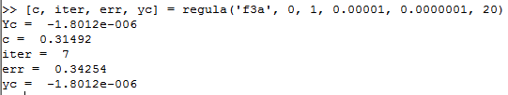

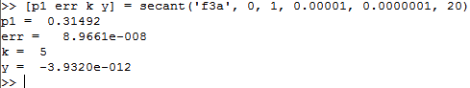3d)

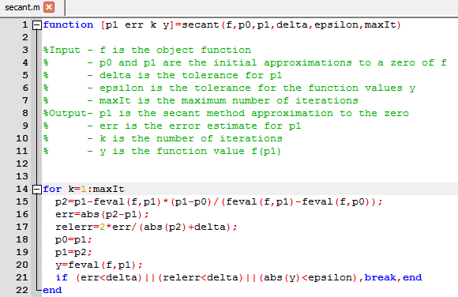

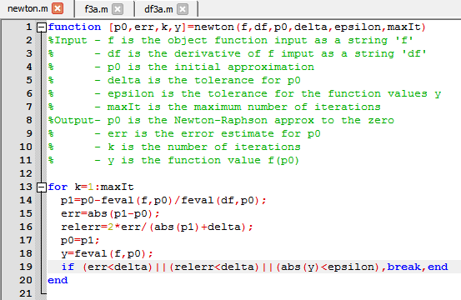

3e)

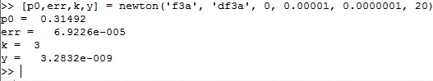

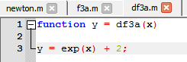

4a) 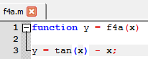

Matlab’s fzero built in function does not return the correct solution

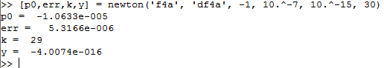4d)

see newton.m from question 3e as I used the same function here

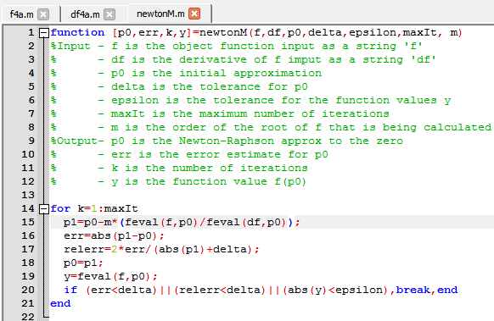4e)

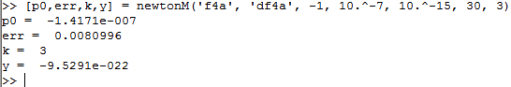

The modified newton method converges significantly faster, converging to a more accurate answer in 3 iterations vs. the unmodified newton method converging in 29 iterations

5c) Converges in 1 iteartions

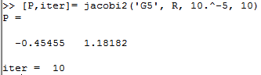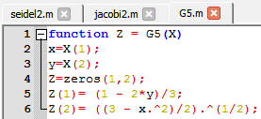

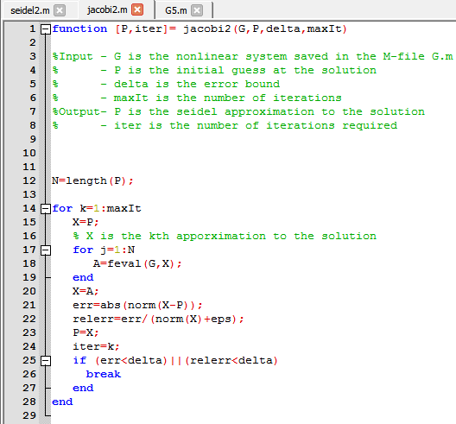

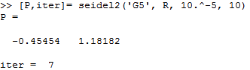5d) Converges in 7 iterations

